**Individual Assignment Minor Data-Driven Decision Making**

Objective: Enhance your understanding and application of data-driven decision making through a curated selection of videos, leading to the development of a minimum viable data product. This is a journey of exploration and creativity, where the process of discovery is at least as important as the final product.

**Overview**

We have carefully selected an extensive collection of videos to deepen your knowledge in various key areas of data-driven decision making, including machine learning, artificial intelligence, data analysis, visualization, application development, cutting-edge technologies, specialized applications, and quality assurance. Take this opportunity to explore, learn, and create something unique.

**Assignment Details**

1. **Exploration:** Begin your journey by exploring our curated collection of videos. Watch as many as you like until you find something that truly resonates with you.
2. **Selection:** Choose at least one video that sparks your curiosity or passion. This video will serve as the cornerstone of your exploration journey.
3. **In-depth Study:** Dive deep into the topic of the selected video. Understand the methodologies, technologies, and concepts discussed. This phase is crucial for building a solid foundation for your project.
4. **Experiment and Create:** Develop a minimum viable data product inspired by the video and your exploration. Let your creativity flow – your data product could be a model, an application, a visualization, or any other form of data-driven creation. Focus on the joy of making and learning.
5. **Presentation:** Conclude your assignment by preparing a presentation of your data product. This presentation should not only showcase your final product but also detail the journey you undertook to get there, including how the video inspired your approach, the creative process, and the insights gained.

**Deliverables**

* A concise report on your exploration journey, including the rationale behind your video selection and an in-depth analysis of topics covered in the chosen video.
* Documentation of your creative process, including data sources, methodologies, and technologies used. Highlight the fun and experimentation aspects of the process.
* A short video (max. 15 minutes) containing your final presentation. The video should be uploaded to YouTube and the link shared with the instructors. If you do not want to make your video publicly available, you can set it to unlisted.

This assignment is an opportunity to not only deepen your understanding of data-driven decision making but also to apply your skills in a meaningful and enjoyable way. We encourage creativity, critical thinking, and a problem-solving mindset throughout this journey. Remember, the joy of making and learning is the heart of this assignment. Good luck!

**Creative Tips for MVP Development**

Embarking on your individual Minimum Viable Product (MVP) project presents a unique set of challenges and opportunities for growth. By focusing on creativity, continuous learning, and enjoyment, you can make the most out of this journey. Below are essential tips designed to help you navigate and excel in your MVP development journey.

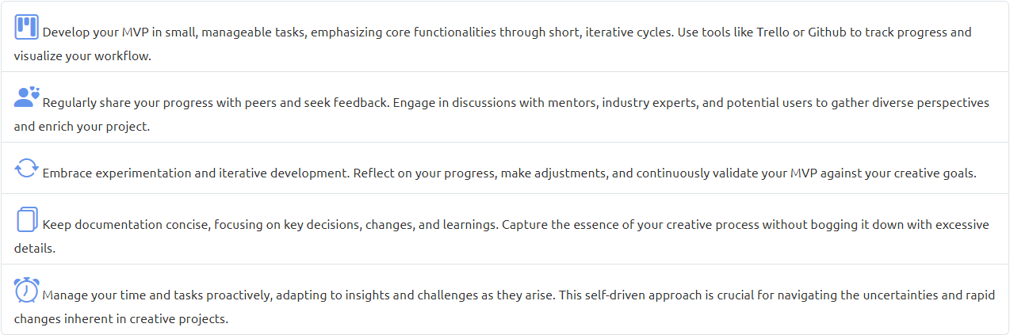

**Grading**

The focus of this assignment lies specifically on the development of minimum viable data products. It emphasizes creativity, exploration, validated learning, user feedback, and iterative design. Below are the criteria for evaluating the creation and development of MVPs in the context of data products.

The criteria are designed to be applicable across a wide range of MVP developments, focusing on the explorative, user-centric, and iterative nature of creating viable data products with technology. This approach encourages a holistic view of product development, highlighting the importance of creativity, learning, and technological robustness.

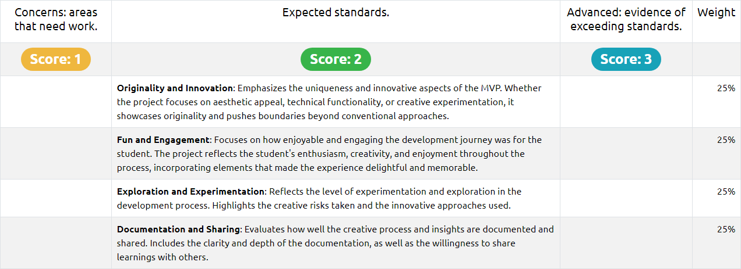**Rubric**

* 3 = Standards are exceeded, excellent performance
* 2 = Most of the expected standards are met, along with a very good performance
* 1 = Although some of the expected standards are met, the performance could be significantly improved

**If two or more criteria fall below the expected standards, the final score will automatically be set to 1.**

[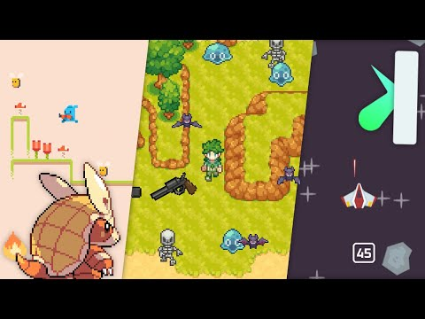](https://www.youtube.com/embed/8OMghdHP-zs?feature=oembed)

(Other Sources of Inspiration:   
<https://www.youtube.com/watch?v=waY3LfJhQLY>  
<https://www.youtube.com/watch?v=B6DrRN5z_uU>

Creating a game from scratch and understanding how to manipulate data

Concepts which I learned:

* Creating a display surface (The canvas that everything will be drawn on, you can only have one at a time)
* Event Loop (Checks events: Keyboard, mouse & controller input, timers) which also includes pressing X to close a game (UI Interactions)

For this project I will be using Pygame in order to create a video game. The reason I picked PyGame is because it seems to be the most basic and default framework. PyGame is easy to learn, however, there is a limited toolset and you don’t get to use things like Unity and other engines. The reason I like this is because it will help me get a thorough understanding of how to program, provide me with a hands on experience, and help me understand the basic metrics and foundation of programming in Python. By using PyGame by itself I will also get much more practice programming than someone using a game engine, as I understand the intricacy of the code behind it.

<https://pyga.me/docs/>

This is a website that provides users/developers with the right commands and prompts to use in order to program games on PyGame.

One of the first obstacles I came across was switching from Spyder to VScode. This IDE was a lot more complicated because there were a lot more options to choose from and the terminal interface was different.

The first obstacle I had to overcome was installing pygame, which ironically didn’t come across immediately, however after consulting ChatGPT I was able to run the code by pasting the following in the terminal:

C:/Users/dtbij/AppData/Local/Programs/Python/Python312/python.exe -m pip install pygame

The reason I’m doing this is because the pyGame directory I had to install was 3.12 whilst the prompt pip install pyGame was installing python 3.10. The two versions were different and therefore gave me an error code.

As I followed along with the video, I managed to create some code. I am using comments in order to annotate the steps I have taken and describe each process along the way:

